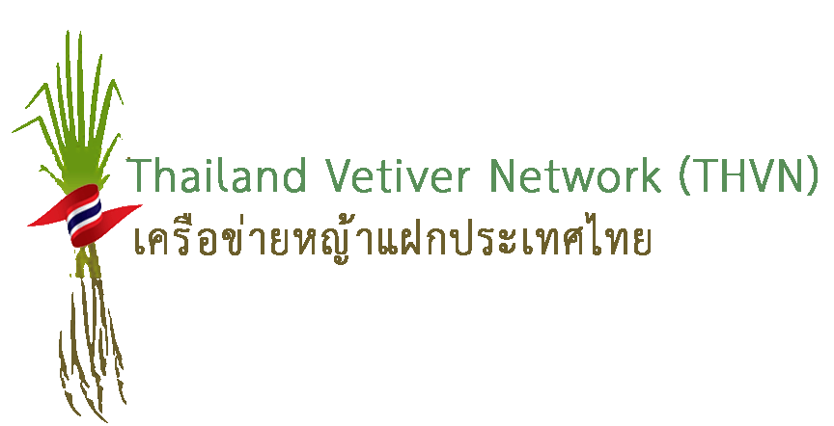
ICV-7
The 7th Internatinal Conference on Vetiver
The King of Thailand Vetiver Awards

On the occasion of the 7th International Conference on Vetiver (ICV-7), which will be held in Chiang Mai, Thailand between 26 – 29 October 2020, Her Royal Highness Princess Maha Chakri Sirindhorn, the Chairperson of His Majesty the King of Thailand’s Chaipattana Foundation, has graciously granted US$10,000 of the King of Thailand Vetiver Awards from the Chaipattana Foundation for four of the most outstanding works on vetiver (prize money of US$ 2,500 each) in the following categories:
- Outstanding Vetiver Research
1.1 Agricultural Application
1.2 Non - agricultural Application
2. Outstanding Dissemination and Application of the Vetiver System
  - Dissemination and Technology Transfer
  - Application of the Vetiver System
In addition, the PTT Public Company Limited’s fund has been approved by Her Royal Highness Princess Maha Chakri Sirindhorn to provide two additional awards (prize money of US$ 2,500 each) for the following categories:
- Outstanding People Participation
  - On-farm Applications and Socio-economic Impacts
  - Disaster Mitigation or Environmental Protection

The six winners will receive the awards from Her Royal Highness Princess Maha Chakri Sirindhorn, the Patron of The Vetiver Network, on His Majesty the King of Thailand’s behalf, during the Opening Ceremony of the 7th International Conference on Vetiver (ICV-7) on 26 October 2020 in Chiang Mai, Thailand. With the support from the Chaipattana Foundation, the recipients of the awards will have the honour to present their papers during the Conference and be covered for the cost of participation at ICV-7 as well as the international travel between their home country and the conference venue, including accommodation during the conference period.
Scientists as well as vetiver practitioners from around the world are invited to apply for the awards by submitting the application form along with the abstract and full paper (soft files are also needed), both of which should conform to the format of the papers, to the following address.
The Selection Committee for the “King of Thailand Vetiver Awards”
Foreign Affairs Group, Division of Planning and Foreign Affairs,
Office of the Royal Development Projects Board
2012 Soi Arun Amarin 36, Arun Amarin Road, Bang Yi Khan Subdistrict,
Bang Phlat District, Bangkok 10700 THAILAND

E-mail: rdpb_vetiver@yahoo.com

- The deadline of the application with the abstract and the full paper is 31 March 2020.
- The announcement of the winners will be made by 31 May 2020.
Specifications for abstract and full paper
The abstract should be between 400-500 words (1 page). The complete work should not be longer than 6,000 words (including figures and pictures, not more than 15 pages). Before submitting, all papers should be edited according to the following norms.
Format: The papers should be submitted as a Microsoft Word document (.doc or .docx), in Times New Roman (TNR) font, according to the following specifications:
- Title: TNR, capital letters, 14 points and bold black, centered;
- Author(s): TNR, 12 points normal. Initial of the first (and second) name(s), last name, institution(s) to which they belong, postal address and e-mail, centered;
- Keywords: TNR, 10 points, maximum five (NOT to include the word ‘vetiver’);
- Text: TNR, 12 points normal, single space, justified;
- Graphs and pictures: In black and white or color. Edit and place in the main text at proper places; and
- Format of page: A-size, margin: 2.5 cm right, top and bottom; and 3 cm for the left; single space.

Contents: The body of the paper should include the following sections: introduction; materials and methods; results and discussion; conclusions and references. Tables and figures should be inserted within the text at appropriate places. References should be included and listed in alphabetical order by last name of the first author according to the following norms: author, (if more than one author, use commas to separate them), year of publication, title, journal (abbrev.), volume, number, pagination (10, and 14 points of line space).
NOTE THIS FORMAT IS SUITABLE FOR RESEARCH PAPERS BUT MAY BE AMENDED FOR SUBMISSIONS THAT ARE NOT RESEARCH BASED
For example:
- Chomchalow, N. and Henle, H.V. (eds.). 1998. Proceedings of the First International Conference on Vetiver. The Office of the Royal Development Projects Board, Bangkok, Thailand.
- Roongthanakiat, N. and Chairoj, P. 2001. Uptake potential of some heavy metals by vetiver grass. Kasetsart J. (Nat.Sci.) 35: 433-440.
- Truong, PNV. 1999. Vetiver grass technology for mines tailings rehabilitation. In: Proceedings of the First Asia-Pacific Conference on Ground and Water Bioengineering for Erosion Control and Slope Stabilization. Manila, The Philippines. pp. 315-325.
Awards Criteria for Consideration
1. Outstanding Vetiver Research
The proposed papers should comply to one or more of the following criteria:
1) Being the study of a researcher or a group of researchers;
2) Being either basic or applied research;
3) Creating new knowledge in such fields as science, agriculture, the environment, or other
fields relating to the development of knowledge on vetiver grass technology;
4) Benefiting the community as a whole. If being basic research, the researcher(s) must
be able to provide the guidelines on how to put their findings into practice.

2. Outstanding Dissemination and Application of the Vetiver System
The proposed papers should comply to one or more following criteria:
1) Manifesting the effective promotion on the use and the actual application of vetiver grass technology;
2) Incorporates the principle of sustainable development;
3) Can be widely applied with no limitations to any particular group;
4) Uses appropriate technology that is environmentally friendly,
5) Supported by scientific facts and is widely accepted; and
6) Supported by an appropriate quantity of work done to show its effectiveness.
3. Outstanding People Participation
The proposed papers should concern works implemented by a group of participating people on a voluntary basis and comply to one or more following criteria:
  - On-farm Applications and Socio-economic Impacts
  - Demonstrating the effective utilization of the vetiver system that yields verifiable benefits particularly in improving soil health and conservation;
  - Demonstrating the multipurpose and interacting benefits of VS when applied at farm level
  - Bringing about the improvement of the quality of people’s lives in terms of social
and economic benefits and showing significant participation of those people affected by the utilization of the vetiver system.
3.2 Disaster Mitigation and/or Environmental Protection
  - Using the vetiver system to benefit the environment, especially through the mitigation of environmental degradation and/or protection of the environment against future problems
  - Demonstrating the principles of sustainable development, both in terms of people participation/engagement and long-term benefits for the environment

The Selection Committee
The Selection Committee for the King of Thailand Vetiver Awards comprises the following members.
- Outstanding Vetiver Research
- Dr. Paul Truong, TVNI Board Member, Technical Director and Director for Asia and Oceania
- Mr. Roley Noffke, TVNI Board Member, Technical Director and Director for South Africa; President, International Erosion Control Association, Region 2
- Dr. Weerachai Nanakorn, Sub-committee on Technical, Monitoring and Evaluation of the Utilization of Vetiver Grass according to the Royal Initiatives

- Outstanding Dissemination and Application of the Vetiver System
- Mr. James Smyle, TVNI President, and Director for the Americas
- Ms. Elise Pinners, TVNI Board Member and Director,
- Dr. Pitayakon Limtong, Sub-committee on Technical, Monitoring and Evaluation of the Utilization of Vetiver Grass according to the Royal Initiatives

3. Outstanding People Participation
  - On-farm Applications and Socio-economic Impacts
1) Mr. Richard Grimshaw, TVNI Founder and Board Member and Director
2) Dr. Dale Rachmeler, TVNI Board Member and Director
3) Dr. Narong Chomchalow, Sub-committee on Technical, Monitoring and Evaluation
of the Utilization of Vetiver Grass according to the Royal Initiatives
3.2 Disaster Mitigation and/or Environmental Protection
1) Mr. Richard Grimshaw, TVNI Founder and Board Member and Director
2) Dr. Dale Rachmeler, TVNI Board Member and Director
3) Mr. Surapol Sanguankaeo, Sub-committee on Technical, Monitoring and Evaluation
of the Utilization of Vetiver Grass according to the Royal Initiatives

APPLICATION FORM
ICV-7
The 7th Internatinal Conference on Vetiver
The King of Thailand Vetiver Awards

Title | Mr., Mrs., Ms., Prof., Dr., Other
Name - Surname
Affiliation/
organization:
Contact Address
Country
Tel.
Email Address(es)

Title of paper
Type of work | Research:  ( ) Agricultural Application  ( ) Non-agricultural Application  Dissemination and Application:  ( ) Dissemination and Technology Transfer  ( ) Application of the Vetiver System  People Participation:  ( ) On-farm Applications and Socio-economic Impacts  ( ) Disaster Mitigation or Environmental Protection
Author(s)
Contribution to the theme of the conference “Vetiver for Soil and Water Conservation:
In Commemoration of King Bhumibol Adulyadej”

